Spring JdbcTemplate 範例

Spring JdbcTemplate是一種連接資料庫和執行 SQL 查詢的強大機制。它內部使用了 JDBC API，但消除了 JDBC API 的很多問題。
JDBC API的問題如下：
- 我們需要在執行查詢之前和之後編寫大量代碼，例如建立連接、語句、關閉結果集、連接等。
- 我們需要對資料庫邏輯執行異常處理程式碼。

Spring JdbcTemplate的優勢
Spring JdbcTemplate 消除了上面提到的 JDBC API 的所有問題。它為您提供了直接編寫查詢的方法，因此可以節省大量工作和時間。

JdbcTemplate類別
它是 Spring JDBC 支持類別中的核心類別。它負責資源的建立和釋放，例如連接物件的建立和關閉等。因此，如果您忘記關閉連接，也不會導致任何問題。
它通過org.springframework.dao包中定義的異常類別來處理異常並提供信息性異常消息。
我們可以在 JdbcTemplate 類的幫助下執行所有數據庫操作，例如從資料庫中插入、更新、刪除和檢索數據。
讓我們看看spring JdbcTemplate類的方法。
N0 | 方法 | 描述
1) | public int update(String query) | 用於插入、更新和刪除記錄。
2) | public int update(String query,Object... args) | 用於使用給定參數使用 PreparedStatement 插入、更新和刪除記錄。
3) | public void execute(String query) | 用於執行 DDL 查詢。
4) | public T execute(String sql, PreparedStatementCallback action) | 使用 PreparedStatement 回調執行查詢。
5) | public T query(String sql, ResultSetExtractor rse) | 用於使用 ResultSetExtractor 獲取記錄。
6) | public List query(String sql, RowMapper rse) | 用於使用 RowMapper 獲取記錄。

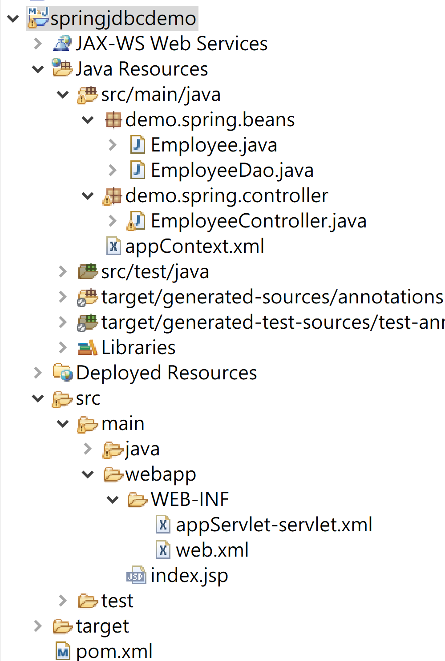
web.xml
<?xml version="1.0" encoding="UTF-8"?>
<web-app xmlns:xsi="http://www.w3.org/2001/XMLSchema-instance"
xmlns="http://xmlns.jcp.org/xml/ns/javaee"
xsi:schemaLocation="http://xmlns.jcp.org/xml/ns/javaee http://xmlns.jcp.org/xml/ns/javaee/web-app_4_0.xsd"
id="WebApp_ID" version="4.0">
<display-name>springjdbcdemo</display-name>
<welcome-file-list>
<welcome-file>index.html</welcome-file>
<welcome-file>index.jsp</welcome-file>
<welcome-file>index.htm</welcome-file>
<welcome-file>default.html</welcome-file>
<welcome-file>default.jsp</welcome-file>
<welcome-file>default.htm</welcome-file>
</welcome-file-list>
<filter>
<filter-name>characterEncodingFilter</filter-name>
<filter-class>org.springframework.web.filter.CharacterEncodingFilter</filter-class>
<init-param>
<param-name>encoding</param-name>
<param-value>UTF-8</param-value>
</init-param>
<init-param>
<param-name>forceEncoding</param-name>
<param-value>true</param-value>
</init-param>
</filter>
<filter-mapping>
<filter-name>characterEncodingFilter</filter-name>
<url-pattern>/*</url-pattern>
</filter-mapping>

<!-- Processes application requests -->
<servlet>
<servlet-name>appServlet</servlet-name>
<servlet-class>org.springframework.web.servlet.DispatcherServlet</servlet-class>
<load-on-startup>1</load-on-startup>
</servlet>

<servlet-mapping>
<servlet-name>appServlet</servlet-name>
<url-pattern>/</url-pattern>
</servlet-mapping>

</web-app>

appServlet-servlet.xml

<beans xmlns="http://www.springframework.org/schema/beans"
xmlns:xsi="http://www.w3.org/2001/XMLSchema-instance"
xmlns:p="http://www.springframework.org/schema/p"
xmlns:context="http://www.springframework.org/schema/context"
xmlns:mvc="http://www.springframework.org/schema/mvc"
xsi:schemaLocation="http://www.springframework.org/schema/beans
http://www.springframework.org/schema/beans/spring-beans-4.1.xsd
http://www.springframework.org/schema/context
http://www.springframework.org/schema/context/spring-context-4.1.xsd
http://www.springframework.org/schema/mvc
http://www.springframework.org/schema/mvc/spring-mvc-4.1.xsd">

<context:annotation-config />
<mvc:annotation-driven />
<context:component-scan
base-package="demo.spring" />

<!-- Handles HTTP GET requests for /resources/** by efficiently serving
up static resources in the ${webappRoot}/resources directory -->
<mvc:resources mapping="/resources/**"
location="/resources/" />

<!-- Resolves views selected for rendering by @Controllers to .jsp resources
in the /WEB-INF/views directory -->
<bean
class="org.springframework.web.servlet.view.InternalResourceViewResolver">
<property name="prefix" value="/WEB-INF/views/" />
<property name="suffix" value=".jsp" />
</bean>
</beans>

Employee.java
package demo.spring.beans;

public class Employee {
int employeeNumber;
String firstName;
String lastName;
String email;
String extension;
String jobTitle;
int reportsTo;
String officeCode;
public Employee() {
}

public Employee(int employeeNumber, String firstName, String lastName, String email, String extension,
String jobTitle, int reportsTo, String officeCode) {

this.employeeNumber = employeeNumber;
this.firstName = firstName;
this.lastName = lastName;
this.email = email;
this.extension = extension;
this.jobTitle = jobTitle;
this.reportsTo = reportsTo;
this.officeCode = officeCode;
}

public String getLastName() {
return lastName;
}

public void setLastName(String lastName) {
this.lastName = lastName;
}

public int getReportsTo() {
return reportsTo;
}

public void setReportsTo(int reportsTo) {
this.reportsTo = reportsTo;
}

public String getOfficeCode() {
return officeCode;
}

public void setOfficeCode(String officeCode) {
this.officeCode = officeCode;
}

public int getEmployeeNumber() {
return employeeNumber;
}

public void setEmployeeNumber(int employeeNumber) {
this.employeeNumber = employeeNumber;
}

public String getFirstName() {
return firstName;
}

public void setFirstName(String firstName) {
this.firstName = firstName;
}

public String getEmail() {
return email;
}

public void setEmail(String email) {
this.email = email;
}

public String getJobTitle() {
return jobTitle;
}

public void setJobTitle(String jobTitle) {
this.jobTitle = jobTitle;
}

public String getExtension() {
return extension;
}

public void setExtension(String extension) {
this.extension = extension;
}

@Override
public String toString() {
return "Employee [employeeNumber=" + employeeNumber + ", firstName=" + firstName + ", lastName=" + lastName
+ ", email=" + email + ", extension=" + extension + ", jobTitle=" + jobTitle + ", reportsTo="
+ reportsTo + ", officeCode=" + officeCode + "]";
}
}

appContext.xml
<?xml version="1.0" encoding="UTF-8"?>
<beans xmlns="http://www.springframework.org/schema/beans"
xmlns:xsi="http://www.w3.org/2001/XMLSchema-instance"
xmlns:p="http://www.springframework.org/schema/p"
xsi:schemaLocation="http://www.springframework.org/schema/beans
http://www.springframework.org/schema/beans/spring-beans-4.0.xsd">

<bean id="ds"
class="org.springframework.jdbc.datasource.DriverManagerDataSource">
<property name="driverClassName"
value="com.mysql.cj.jdbc.Driver"></property>
<property name="url"
value="jdbc:mysql://localhost:3306/classicmodels?useUnicode=true&amp;characterEncoding=utf-8"></property>
<property name="username" value="root"></property>
<property name="password" value="1234"></property>
</bean>
<bean id="jt" class="org.springframework.jdbc.core.JdbcTemplate">
<property name="dataSource" ref="ds"></property>
</bean>
<bean id="dao" class="demo.spring.beans.EmployeeDao">
<property name="template" ref="jt"></property>
</bean>
</beans>

EmployeeDao.java

package demo.spring.beans;

import org.springframework.jdbc.core.JdbcTemplate;

public class EmployeeDao {
JdbcTemplate jdbcTemplate;

public void setTemplate(JdbcTemplate template) {
this.jdbcTemplate = template;
}

public int saveEmployee(Employee e){
String query="insert into employees(employeeNumber,firstname,lastname,extension,email,officecode,reportsTo,jobTitle) values(%d,'%s','%s','%s','%s','%s',%d,'%s')";
String sql=String.format(query, e.getEmployeeNumber(),e.getFirstName(),e.getLastName(),e.getExtension(),e.getEmail(),e.getOfficeCode(),e.getReportsTo(),e.getJobTitle());
return jdbcTemplate.update(sql);
}
public int updateEmployee(Employee e){
String query="update employees set extension='"+e.getExtension()+"',jobTitle='"+e.getJobTitle()+"' where employeeNumber="+e.getEmployeeNumber();
return jdbcTemplate.update(query);
}
public int deleteEmployee(Employee e){
String query="delete from employees where employeeNumber="+e.getEmployeeNumber();
return jdbcTemplate.update(query);
}
}
EmployeeController.java

package demo.spring.controller;

import java.util.List;
import org.springframework.beans.factory.annotation.Autowired;
import org.springframework.context.ApplicationContext;
import org.springframework.context.support.ClassPathXmlApplicationContext;
import org.springframework.stereotype.Controller;
import org.springframework.ui.Model;
import org.springframework.web.bind.annotation.PathVariable;
import org.springframework.web.bind.annotation.RequestMapping;
import org.springframework.web.bind.annotation.ResponseBody;

import demo.spring.beans.*;

@Controller
public class EmployeeController {

@RequestMapping(value="/emp")
@ResponseBody
public String employee(){
ApplicationContext ctx=new ClassPathXmlApplicationContext("appContext.xml");

EmployeeDao dao=(EmployeeDao)ctx.getBean("dao");
Employee e=new Employee();
e.setEmployeeNumber(1900);
e.setFirstName("Dean");
e.setLastName("Lee");
e.setExtension("0x1357");
e.setEmail("dean@demo.com");
e.setReportsTo(1056);
e.setJobTitle("Sales");
e.setOfficeCode("1");
int status=dao.saveEmployee(e);
return ""+status;
}
}

